**LetsUpgrade Linux Administration Essentials Course Batch 1**

**Assignment Day 8 | 9th December 2020**

Student Name: Kartick K

Email-id: [kartickkripa@gmail.com](mailto:kartickkripa@gmail.com)

**Assignment 0**

Script

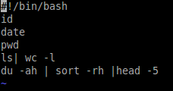

Execution & Result

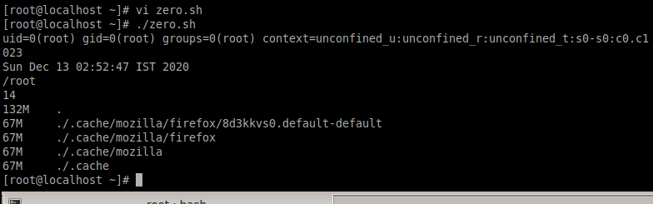

**Assignment 1**

Creation of script



Main Code:

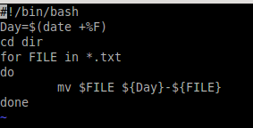

Before running script



After running script



**Assignment 2**

Script

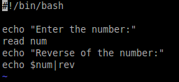

Execution and Result

